[INTRODUCTION TO SEMANTIC WEB](https://app.schoology.com/course/1644863589)

Assignment 1A



BS(SE)-2015

Submitted by:

Sania Shoaib 2015/COMP/BSSE/18679 1518549

Course Advisors:

Ms Tehreem Qamar

Structuring Web Documents in XML

1. Draw tree structure of the following XML document

<classlist class="1264">

<group number="1">

<groupname>Rapid Development</groupname>

<grouplist>

<name>Steve Bell</name>

<name>Jo McDuff</name>

</grouplist>

</group>

<group number="2">

<groupname>Rapid Development</groupname>

<grouplist>

<name>Steve Smith</name>

<name>Jo Brown</name>

</grouplist>

</group>

</classlist>

Solution:

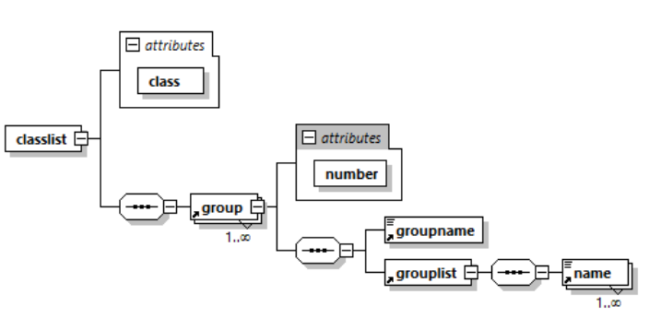

M

1. Define a DTD that validates following documents
   1. Student.xml

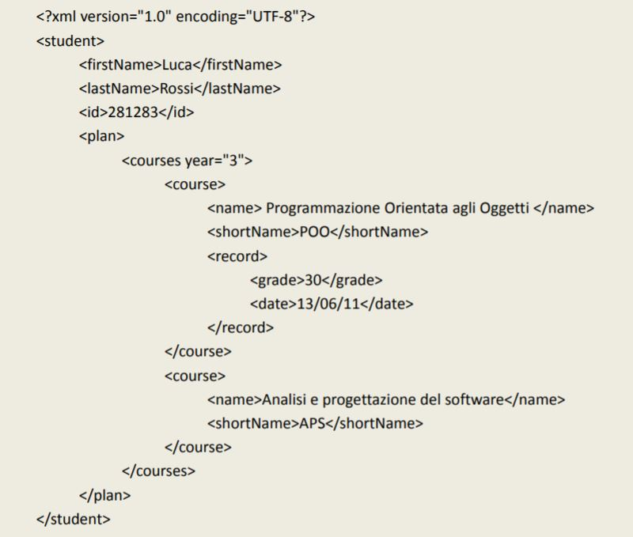

Solution:

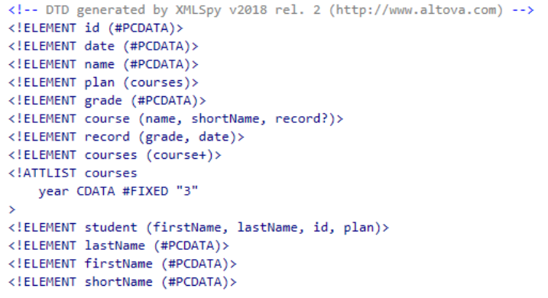

* 1. Parts.xml

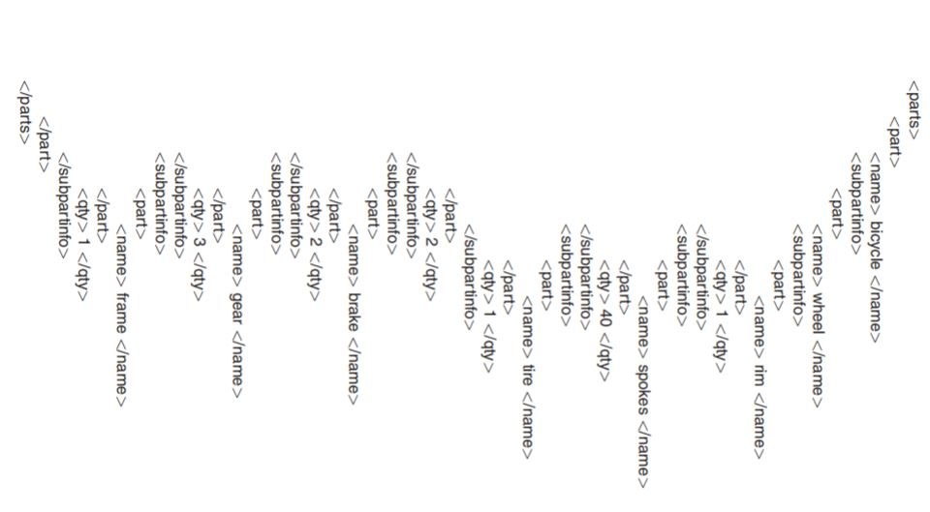

Solution:

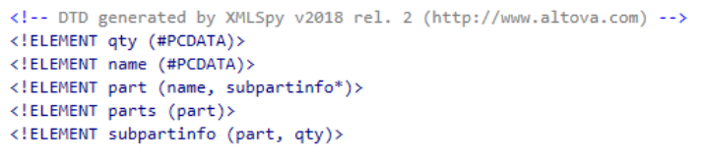

* 1. 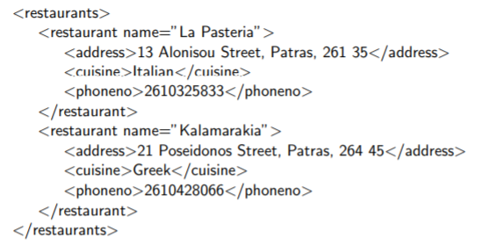Restraunts.xml

Solution:

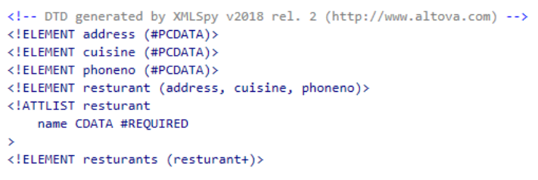

1. Write XML that validates following DTDs
   1. Catalog.dtd

<!DOCTYPE CATALOG [  
  
<!ENTITY AUTHOR "John Doe">  
<!ENTITY COMPANY "JD Power Tools, Inc.">  
<!ENTITY EMAIL "jd@jd-tools.com">  
  
<!ELEMENT CATALOG (PRODUCT+)>  
  
<!ELEMENT PRODUCT  
(SPECIFICATIONS+,OPTIONS?,PRICE+,NOTES?)>  
<!ATTLIST PRODUCT  
NAME CDATA #IMPLIED  
CATEGORY (HandTool|Table|Shop-Professional) "HandTool"  
PARTNUM CDATA #IMPLIED  
PLANT (Pittsburgh|Milwaukee|Chicago) "Chicago"  
INVENTORY (InStock|Backordered|Discontinued) "InStock">  
  
<!ELEMENT SPECIFICATIONS (#PCDATA)>  
<!ATTLIST SPECIFICATIONS  
WEIGHT CDATA #IMPLIED  
POWER CDATA #IMPLIED>  
  
<!ELEMENT OPTIONS (#PCDATA)>  
<!ATTLIST OPTIONS  
FINISH (Metal|Polished|Matte) "Matte"  
ADAPTER (Included|Optional|NotApplicable) "Included"  
CASE (HardShell|Soft|NotApplicable) "HardShell">  
  
<!ELEMENT PRICE (#PCDATA)>  
<!ATTLIST PRICE  
MSRP CDATA #IMPLIED  
WHOLESALE CDATA #IMPLIED  
STREET CDATA #IMPLIED  
SHIPPING CDATA #IMPLIED>  
<!ELEMENT NOTES (#PCDATA)>  
]>

Solution:

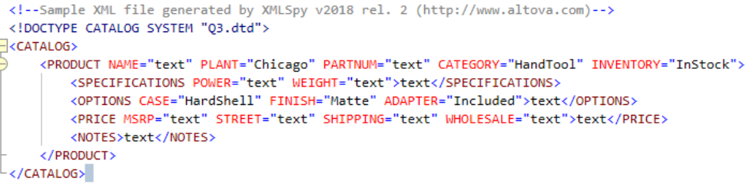

* 1. Recipes.dtd

<!ELEMENT collection (description,recipe*)>

<!ELEMENT description ANY>

<!ELEMENT recipe (title,ingredient*,preparation,comment?,nutrition)>

<!ELEMENT title (#PCDATA)>

<!ELEMENT ingredient (ingredient*,preparation)?>

<!ATTLIST ingredient name CDATA #REQUIRED

amount CDATA #IMPLIED

unit CDATA #IMPLIED>

<!ELEMENT preparation (step*)>

<!ELEMENT step (#PCDATA)>

<!ELEMENT comment (#PCDATA)>

<!ELEMENT nutrition EMPTY>

<!ATTLIST nutrition protein CDATA #REQUIRED

carbohydrates CDATA #REQUIRED

fat CDATA #REQUIRED

calories CDATA #REQUIRED

alcohol CDATA #IMPLIED>

Solution:

